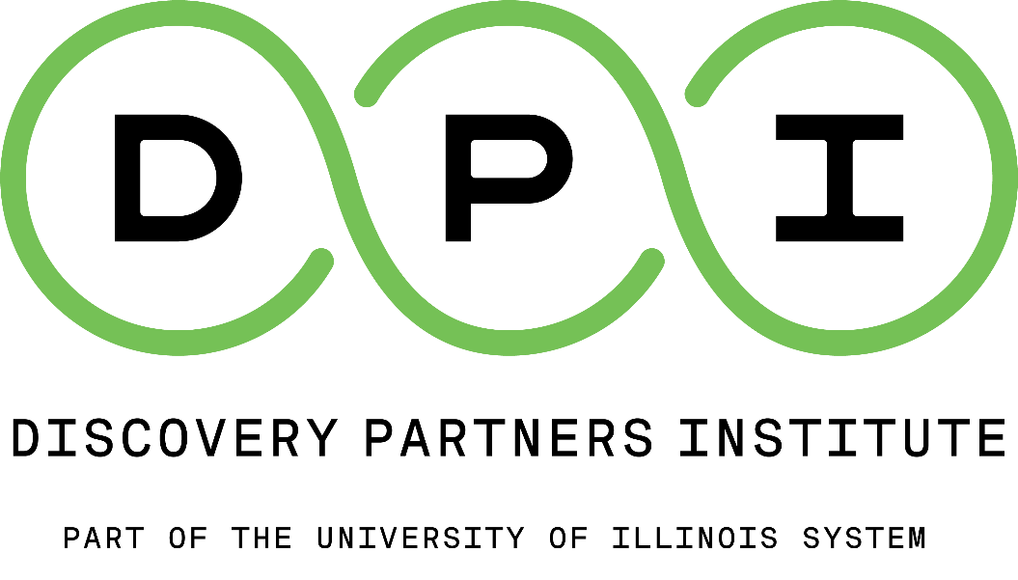

Community Education | Pritzker Tech Talent Labs
Participant Handbook 2023-2024

Welcome!
Welcome to the Discovery Partners Institute (DPI), part of the University of Illinois (U of I) System! We’re excited you’ve chosen to participate in programming offered by the Community Education Unit of the Pritzker Tech Talent Labs. To help make the most of your experience at DPI, this Participant Handbook provides information about DPI and the Community Education Unit, as well as presents the guidelines and expectations all participants are expected to follow.

Vision and Mission of the Discovery Partners Institute
DPI’s Vision is to be a magnet for the most ambitious talent Illinois has to offer. Our Mission? We do three things – Tech Talent Development, Applied Research and Development, and Business Building.
- Tech Talent Development: DPI prepares promising and diverse Illinoisans to step into lucrative and resilient tech jobs.
- Applied R&D: DPI is a place where companies, researchers, and students can access smart people, advanced equipment, and funding to turn their ideas into new products.
- Business Building: DPI strives for equitable economic development by looking to grow businesses from university research and supporting start-ups and mid-sized companies looking to grow.

Our Commitment to Diversity
Diversity, Equity & Inclusion are a core foundation of our programs — not an afterthought. In 2022, the U of I System’s computer science, computer engineering, and data/information science programs graduated almost 3,000 people: just 2.2% were Black and 5.7% were Hispanic. We must do better.
- Design: DPI will intentionally design programs to address key challenges & friction points that have historically disadvantaged underrepresented groups in tech.
- Partner: We will partner with organizations that have relationships with underrepresented communities to build deep connections with the local tech community.
- Support: DPI will systematically support a learner’s journey with wraparound services to ensure success.
- Build: Internally, DPI is building a representative workforce and will conduct business with a diverse supplier base.

Community Education – Pritzker Tech Talent Labs Unit
The Community Education unit provides programming for middle, high school, community college, 4-year and graduate students, and K-12 educators to develop skills and learning pathways into computing and tech-related fields. Community Education programs aim to
- increase the participation of Black, LatinX, female, and other historically minoritized populations in computer science, data science, and related fields of study at Illinois institutions.
- advance pathways into DPI’s Pritzker Tech Talent Labs programs and help participants thrive in Chicago’s tech ecosystem.
- develop systemic and holistic programs that create capacity for computer science education and build a better coordinated pathway for students in computing by aligning K-12, 2-year and 4-year institutions, non-profits, community-based entities, and employers.

Community Education Leadership
Mark Harris provides leadership to the Community Education Unit. Sub-units within Community Education plan are organized by student grade and/or programming purpose. Names and contact information for all Community Education personnel are included below.

Community Education Unit | Mark Harris, Director | markh3@uillinois.edu
K-9 Programming | Gina Grant, Associate Director | glgrant@uillinois.edu
 | Jaclyn Carmichael, Assistant Director | jaclync@uillinois.edu
High School Programming | Kay Monelle, Associate Director | kaym@Uillinois.edu
 | Lindsey Vetvick, Assistant Director | lvetvick@uillinois.edu
Community College Pathways | Stephanie DeCicco, Associate Director | decicco@uillinois.edu
Teacher Education | Danna Dotson-Simmons, Associate Director | ddotson2@uillnois.edu
 | Todd McFarlin, Assistant Director | tmcfar1@uillinois.edu
External Relations | Karen Larson | kplarson@uillinois.edu
Recruitment | Tony Torres | ttorres3@uillinois.edu

Participant Eligibility
Although DPI’s Community Education programming is focused on increasing the participation of Black, LatinX, female, and other historically minoritized populations in computer science, data science, and related fields of study at Illinois institutions, enrichment programming for middle grades (6th-8th), high school, community college, 4-year and graduate learners, and educators is open to all.

PARTICIPANT EXPECTATIONS
Community Education programming offers participants opportunities to engage in interesting activities and experiences that promote critical thinking, develop knowledge, and encourage independence. Participants can also build friendships with others and make connections to the Chicago tech ecosystem.

Standards of Behavior
DPI has a vision for its participants that encompasses a positive outlook on learning, joyful and active involvement, and confident participation. To promote an environment where this vision can be realized, program participants agree to follow the following behavioral standards to ensure the success of programming and the health and safety of the learning community. Program participants agree to:
- Attend program sessions regularly and on time.
- Be active and engaged in all lessons and activities, including participating in classroom conversations and being respectful and attentive.
- Complete work and assignments in a timely fashion.
- Offer original thoughts and responses to others in class discussions and in writing.
- Maintain academic integrity.
- Appropriately challenge one another and encourage respectful and constructive dialogue.
- Have an open mind to new ways of thinking, working, studying, teaching, reading, and writing.
- Contribute to your own educational experience.

Participant Code of Conduct
DPI is committed to providing a safe, productive, and welcoming environment for participants in all its programs. This includes respectful treatment of everyone regardless of gender, gender identity or expression, sexual orientation, disability, physical appearance, age, body size, race, religion, national origin, ethnicity, level of experience, political affiliation, veteran status, pregnancy, genetic information, as well as any other characteristic protected under state or federal law.

Expected Behavior
- Treat all participants with respect and consideration and value diversity of views and opinions.
- Be considerate, respectful, and collaborative.
- Communicate openly with respect for others.
- Provide feedback on ideas rather than on individuals.
- Gracefully accept feedback.
- Acknowledge the contributions of others.
- Avoid personal attacks directed toward other participants.
- Alert DPI staff immediately if you notice a dangerous situation or someone in distress.
- Respect the rules and policies of the project and venue.

Unacceptable Behavior (includes, but is not limited to)
- Harassment, intimidation, or discrimination in any form
- Physical or verbal abuse by anyone to anyone, including repeated use of pronouns other than those requested
- Unwelcome sexual attention or advances
- Personal attacks directed at others
- Sharing or publishing others’ private information, such as a physical or electronic address, without explicit permission
- Making alarming, intimidating, threatening, or hostile comments

Consequences
- Participants who do not meet program expectations will be counseled accordingly, and specific strategies may be implemented immediately upon recognizing a concern.
- A participant who has been asked to stop unacceptable behavior is expected to immediately comply.
- In rare circumstances, a participant may be removed immediately or later from a session or program by DPI staff or security/local police due to the inability to meet expectations.
- DPI may choose to prohibit attendance at a future session or program.

Reporting Unacceptable Behavior
- If a participant has been subjected to unacceptable and/or unwelcome behavior, is aware of someone else who has been subjected to unacceptable and/or unwelcome behavior, or has any other concerns, please contact the program point of contact immediately.

All participants are required to abide by the Participant Code of Conduct outlined above which complies with the National Science Foundation (NSF) directive (NSF, PAPPG, A.1.g,h).

PROGRAM INFORMATION
Application/Registration
Each individual program within the Community Education Unit manages its own application and registration process. Participants (or parent/guardian, where applicable) must complete all application and registration materials in their entirety including program forms and waivers (see below) prior to the first day of programming to be able to participate. Failure to submit completed documents may delay participation until the documents are received.

Program Cost and Supplies
DPI’s Community Education K-9, High School, and Community College Programs are free of charge to all participants. Program supplies will be provided by DPI.

Program Syllabi
Participants will receive a program syllabus or outline at the program orientation or first session of the program in which they are enrolled which will outline the essential information about the program including expected participant learning outcomes, meeting dates, length of program, attendance guidelines, topics for study, and methods of assessment. It will also contain specific information regarding how to contact the program instructor or coordinator, participant expectations, program procedures and other pertinent information.

Grading
All programming provided by DPI’s Community Education Unit is non-credit enrichment and therefore not formally graded; however, participants are provided meaningful feedback regarding individual program and project objectives, how participants performed in meeting those objectives, and their growth towards mastering those objectives. Please see the specific program syllabus for additional information about program assessment.

Classroom Chaperones
For the health and safety of the DPI community and program participants, all K-9, High School, and Community College programs are always chaperoned by a DPI Staff member whether offered in-person at DPI, at another location or online.

Digital Badges
A Digital Badge is an indicator of accomplishment or skill that can be displayed, accessed, and verified online. Because DPI recognizes the need for learners to continuously build skills with application to industry that expand opportunities to pursue higher education, the Community Education Unit has piloted the use of Digital Badges to represent the successful accomplishment of specific programs. More information about the Community Education Digital Badging is available for some courses within Digital Scholars. Students should see their program coordinator for more information.

Program Forms and Waivers
Participants must complete all required forms and waivers (if applicable) to be able to participate in Community Education programming.
- Participant Handbook Acknowledgement Form: Participants must acknowledge that they’ve received the Student Handbook and agree to adhere to all Participant Expectations. This form can be accessed and acknowledged HERE.

- Talent Waiver: Participants must sign a Talent Waiver granting or declining consent to the use by The Board of Trustees of the University of Illinois of their image, voice, or both; as well as any video, photograph, or audio recording reproduced either in whole or in part from the video, photograph, or audio recording. These materials may or may not be used for fundraising, advertising, publicity, or any other purpose on behalf of either the University or its Foundation. Participants under the age of 18 must have the Talent Waiver signed by a parent/guardian granting or declining consent. This form can be accessed and signed electronically HERE.

- MacBook Loaner Agreement Form: Some programs offered by the Community Education Unit utilize devices such as MacBooks, iPads, and other Apple devices. DPI temporarily loans MacBooks to participants for the duration of the educational program. A completed MacBook Loaner Agreement form must be completed, signed, and returned by each participant to whom a device is provided (participants under the age of 18 must obtain a signature from a parent/ guardian). Any loaded device(s) must be returned within five (5) business days of program completion or conclusion of participation. If a device is not returned within this time frame or is not returned in the same condition in which it was received, the participant (or signatory) will be financially responsible for any damages or replacement costs of the device. This form can be accessed and signed electronically HERE.

- Acceptable Use of Computational Resources Policy: DPI is committed to a respectful, safe, and ethical environment for all members of its community; and as such, adheres to the University of Illinois Chicago’s Acceptable Use of Computational Resources Policy which applies to all academic, research, and administrative departments and offices at the University of Illinois Chicago (including the Discovery Partners Institute); all university faculty, staff, students, alumni, applicants, visitors, contractors and affiliates (university “members’); and all resources in the university computing portfolio including: systems, network infrastructure, devices, facilities and applications (collectively referred to as “computational resources”), whether located on university property or accessed remotely. Receipt of and agreement to follow all rules and expectations as outlined in this Student Handbook constitute participants’ agreement to the Acceptable Use of Computational Resources Policy. The Acceptable Use of Computational Resources Policy can be accessed HERE.

The Family Educational Rights and Privacy Act of 1974 (FERPA)
The Family Education Rights and Privacy Act (FERPA) is a federal act that protects the privacy interests of students. It affords students the right to inspect and review education records maintained about them by an educational institution and, in many cases, decide whether a third party may obtain information from the educational institution about them. Parents of a “dependent student” with proper proof also have the right to inspect their student’s education records. FERPA generally prevents an education agency or institution from sharing student records or personally identifiable information in these records without the written consent of the student. DPI is part of the University of Illinois System, and as such, program participants are protected by FERPA. Participants’ personally identifiable records will not be shared without the written consent of the participant, except as provided by the Act.

ATTENDANCE INFORMATION
Attendance Guidelines
DPI’s programs are developed with collaboration and teamwork in mind. Central to these concepts is consistent and enthusiastic attendance. Participants are expected to attend all sessions of the program in which they are enrolled; however, DPI recognizes that occasionally participants need to be absent when unavoidable conflicts arise. Participants should refer to their specific program syllabus for detailed attendance requirements for that program, as well as notification procedures if they will be absent.

Arrival/Dismissal
DPI prides itself on starting and ending its programming on-time, so participants should arrive to their programming site on time, and no earlier than 10 minutes before the start of the program. Because 200 S. Wacker Drive is a secured building, participants will be escorted to their classrooms on DPI’s designated floors. For the safety of participants and building tenants, only program participants are allowed into the classrooms for programming. Participants will be dismissed from their classroom at the designated program end time. DPI does not provide for the supervision of minors prior to or after programming.

Drop Off and Pick Up
Participants may be dropped off/picked up at the main entrance to DPI’s offices at 200 S. Wacker Drive located off Wacker Drive at Adams Street. For K-9 and high school programming, a DPI staff member will be assigned to this entrance to welcome participants. DPI commits to ending its programming on time, so participants will be dismissed promptly when DPI programming has finished.

Session Cancellations
If severe weather, building closure, or other conditions require the cancellation or late start of a program session, participants will be notified by email no less than two hours before the scheduled session start time at the emergency email address noted on their registration paperwork. Participants can also check the Community Education website at https://dpi.uillinois.edu/tech-talent-development/high-school-and-community-college-student-programs/ weather-related cancellations or start time updates.

PROGRAM DESCRIPTIONS
Community Education programming is organized by grade; therefore, participants are eligible to enroll in programming based upon the grade level in which they are currently enrolled or expected to be enrolled in the upcoming academic year. The programming year begins in the fall: for example, Academic Year 2022-23 programming includes Fall 2022, Spring 2023, and Summer 2023.
- Digital Explorers (DE): DE is designed for middle grade students (6-8th graders). Participants develop computer science skills by coding and building a mobile app using Swift Playgrounds© on the Apple iPad and take part in team building and human-centered design thinking activities.
- Discover Computing (DC): DC is a two-part program series designed for freshman and sophomore high school students (grades 9 and 10) to build interest and awareness in computer science and to advance their personal journeys into tech. Participants explore computing concepts and tools, build a portfolio with creative coding, connect with mentors, and develop skills in problem-solving and team building.
- Digital Scholars (DS): DS is designed for junior and senior high school students, community college students, and incoming college students (grades 11, 12, and 13) interested in a four-year CS college pathway. Participants take non-credit college-level courses in computer science, data science, electrical/computer engineering, and mobile app development; develop college and career readiness skills; and learn about the Chicago tech ecosystem through daily speakers and weekly workshops.
- CPS Computer Science Workshops: CPS Computer Science Workshops are designed for students enrolled in the CPS Exploring Computer Science course (grades 9 through 12). Students learn about the Chicago tech ecosystem, participate in fireside chats with tech professionals, and discuss what it’s like to study CS at a 4-year institution with current undergraduate students.
- Computer Science (CS) Opportunity Fair: The CS Opportunity Fair is designed to motivate and inspire students to study CS in Illinois by bringing together high school students, colleges and universities, representatives from the tech community, and non-profits to discuss the various pathways into tech. The event features panels and presentations from higher education representatives, current CS students, and professionals in the tech community.
- Digital Bridge (DB): DB is designed for incoming and current City Colleges of Chicago students interested in Computer Science, engineering, and tech fields. Participants meet tech professionals, entrepreneurs, and leaders from the Chicago tech ecosystem who share their personal journeys into tech.
- Computer Science (CS) Starter Academy: The CS Starter Fellows Program is designed for community college students (grades 13-14) interested in Computer Science transfer pathways. The program engages and supports students throughout their transfer journey with mentoring, CS advising, career planning, and CS-related workshops.
- CS Teacher Endorsement (CSTed): The CSTed program offers existing professionally licensed Illinois teachers the opportunity to earn an additional endorsement in Computer Science. The online, cohort-based program meets the Illinois State Board of Education (ISBE) 18.0 credit hour requirement and prepares teachers to take the ISBE CS content exam.
- Swift/Mobile App Development Teacher Training Program: The Swift/Mobile App Development program is a self-paced program that provides participants an opportunity to gain programming skills and bring CS concepts into their K-12 classrooms.

200 S. WACKER BUILDING INFORMATION
DPI’s address is 200 S. Wacker Drive, Chicago, IL 60606. Most Community Education programming will be located on the 4th floor of the building, although some programming may be scheduled on the 20th floor. See the specific program syllabus for additional information about classroom location.

Entrances/Exits and Safety Info
200 S. Wacker has two entrances: the main entrance is located on the southwest side of Wacker Drive at Adams Street. There are several revolving doors at this entrance that open directly to the security desk. Participants should use the main entrance when entering the building to join programming. The secondary entrance is on the south side of Adams Street next to the Adams Street bridge.

DPI Classrooms Emergency Exits are located on the 4th and 20th Floor at designated locations. Maps of these exits can be found in Appendix A of this handbook, as well as linked HERE.

Parking and Transportation
DPI’s location at 200 S. Wacker Drive is directly west of Willis Tower and can be reached by bus, train, and automobile. The building does not offer public parking, but there are many metered parking spaces available close by. DPI recommends using a parking app to find the most convenient and reasonably priced parking. The building is just a few steps away from Union Station, CTA trains, and the water taxis. Some Community Education programs include CTA passes as part of programming. Please contact the program point of contact to find out more.

Wireless Guest Access
DPI offers guests of its facility the use of Wireless Network Access while on location. Locate the IllinoisNet_Guest network on the device, click connect, and follow the prompt to login. Users will be prompted to accept Terms of Use prior to connecting.
Visitors
DPI welcomes middle school through college student participants to its programming to develop skills and learning pathways into computing and tech-related fields. Because 200 S. Wacker Drive is a secured building, all program participants are escorted to their classrooms on DPI’s designated floors. For the safety of participants and building tenants, only program participants are permitted into DPI classrooms during programming. If there is a prevailing reason that requires a participant to bring a visitor, please contact the program point of contact to make appropriate arrangements.

LINKS TO FORMS, WAIVERS AND POLICIES

- Participant Handbook Acknowledgement Form

- Talent Waiver Form

- MacBook Loaner Agreement Form

- Acceptable Use of Computational Resources Policy

- National Science Foundation (NSF) Participant Conduct Directive

- Classroom Emergency Exits/Building Safety Information

APPENDICES
- Appendix A: DPI Classrooms Emergency Exits (4th and 20th Floors)
- Appendix B: Participant Handbook Acknowledgement Form

Appendix A – DPI Classrooms Emergency Exits (4th and 20th Floors)
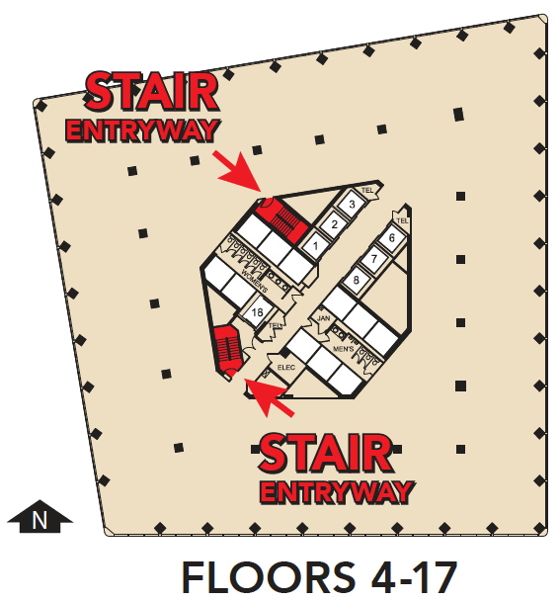

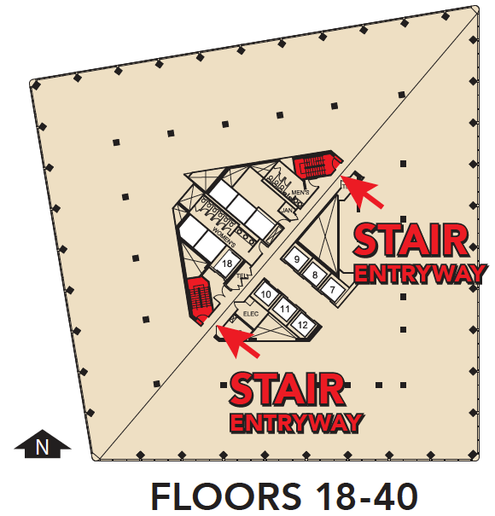
4th Floor
Classrooms A, B, C Discovery Room

20th Floor
Classroom 2032

Appendix B – Participant Handbook Acknowledgement Form
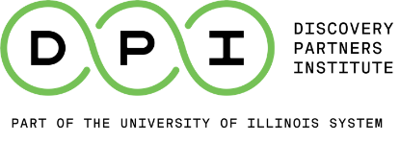

Community Education – Pritzker Tech Talent Labs
Participant Handbook Acknowledgement Form

I have received a copy of the Community Education Participant Handbook and have read and understand all the rules and expectations. I agree to be responsible for following all the rules and expectations of being a DPI participant and understand the consequences for failing to follow the requirements.

I understand that this handbook may be amended at any time without notice. The most updated version of this handbook is available on the Discovery Partners Institute website (https://dpi.uillinois.edu/tech-talent-development/community-education/) and is applicable to all participants upon the implementation of any change. Community Education Leadership will notify participants in writing, where possible, of any changes to the handbook as soon as is practical.

Participant Name:

Participant Signature: Date:

Parent/Guardian Name (if applicable):

Parent’s/Guardian Signature (if applicable): Date:

Email this form to CommunityEd-group@office365.illinois.edu or submit to Program Point of Contact.

